**Synthetic Data Generation Prompts through Mockaroo**

1. We have generated ID schema which includes primary keys for all schemas. We update dataset once satisfied with preview.

1. **Schemas:**  
   **Customer** – We have generated customer schema with the below logics. We update dataset once satisfied with preview.

All field names and schema type. For customer postcode, we generated 50 real UK postcode to fill in the database of customers. All customers ae assumed to have registered before 6-1-22. All phone numbers generated are unique 10 digit number.

Customer Address and Customer City – We put in formula for placing the real address as per the postcode and we have formulated the cities as per the real Postal codes

**Order-** We have generated customer schema with the below logics. We update dataset once satisfied with preview.

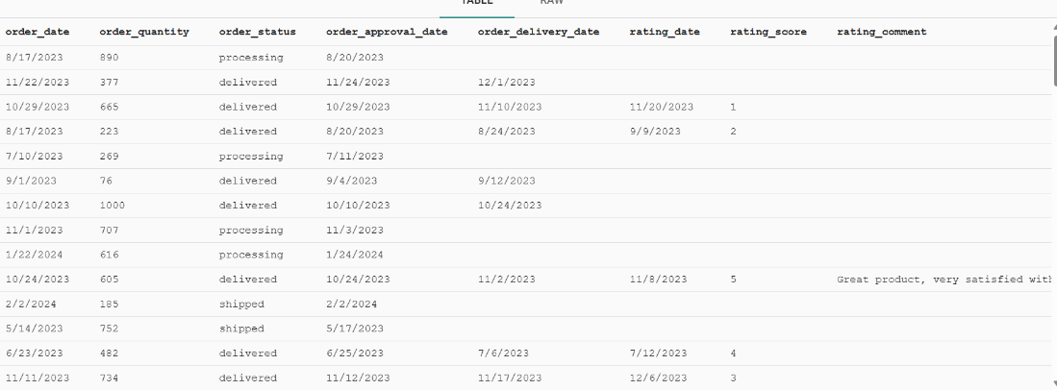

All field names and schema type.

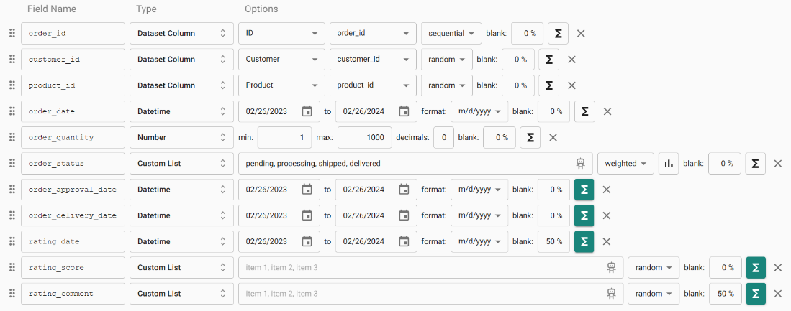

order_approval_date

We keep the Order approval date as always more than order date by a range of 10 days

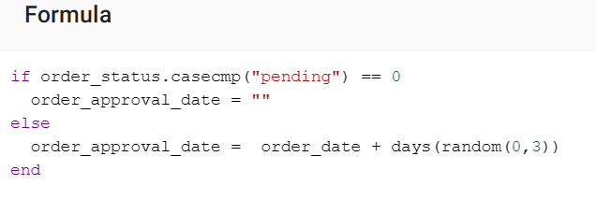

Order delivery date

We keep the order delivery date as always more than order date by atleast 10 days and atmost 30 days

Rating_date

We keep the order delivery date as always more than order date by atleast 15 days and atmost 25 days

We keep the rating data as 50% blank

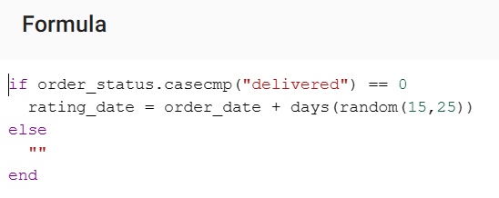

rating_score

We keep rating score as random value from 1 to 5 only in case if the review date is recorded

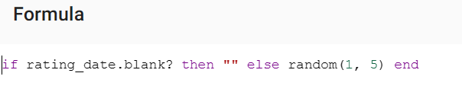

order_status

If order staus is delivered then that order must have recorded the order delivery date and the order delivery date must be more than order date by the value range from 4 to 14.

The weights provided to the order status is as follows:

Weights

Pending-5  
Shipped-10  
Processing-10  
Delivered-75

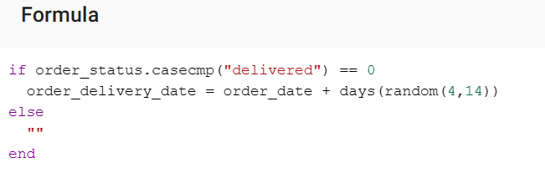

Rating_comment

Randomly select the comments from the given comments domain

Keep 50% of the rating comment values as blank

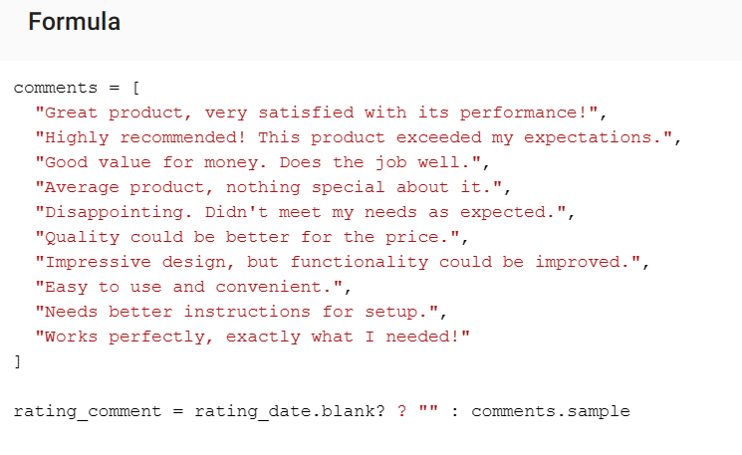

**Products**

Discount_price

Discounted price is the price after applying the discount to the original price

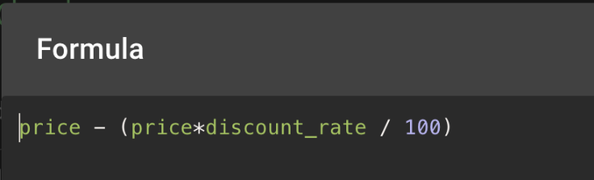

**Supplier**

Supplier_address   
Including postcodes and cities, we put in formula for placing the real address as per the postcode and, we have formulated the cities as per the real Postal codes

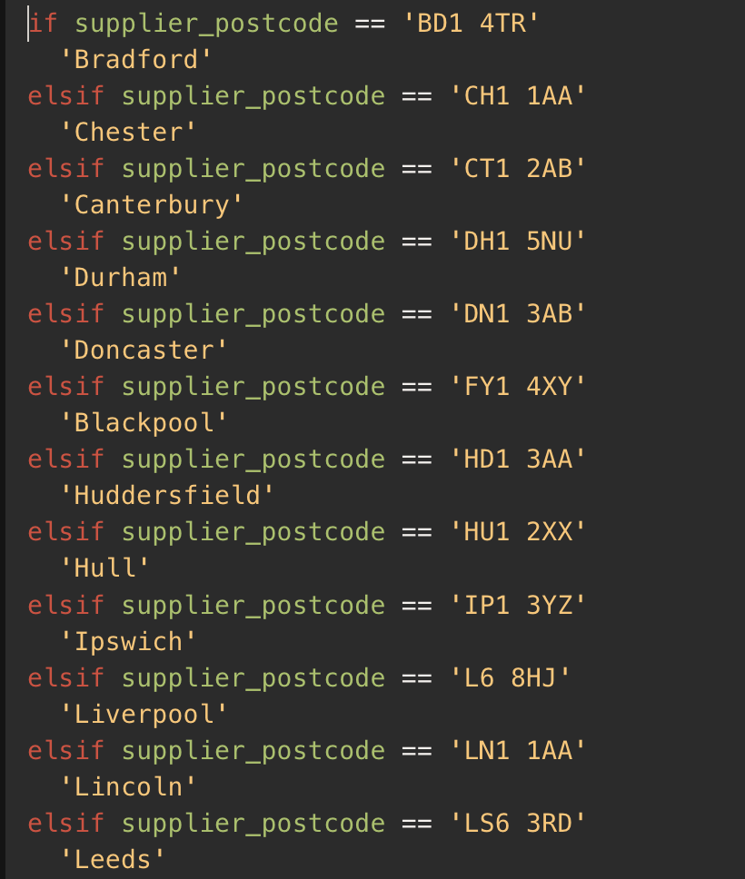

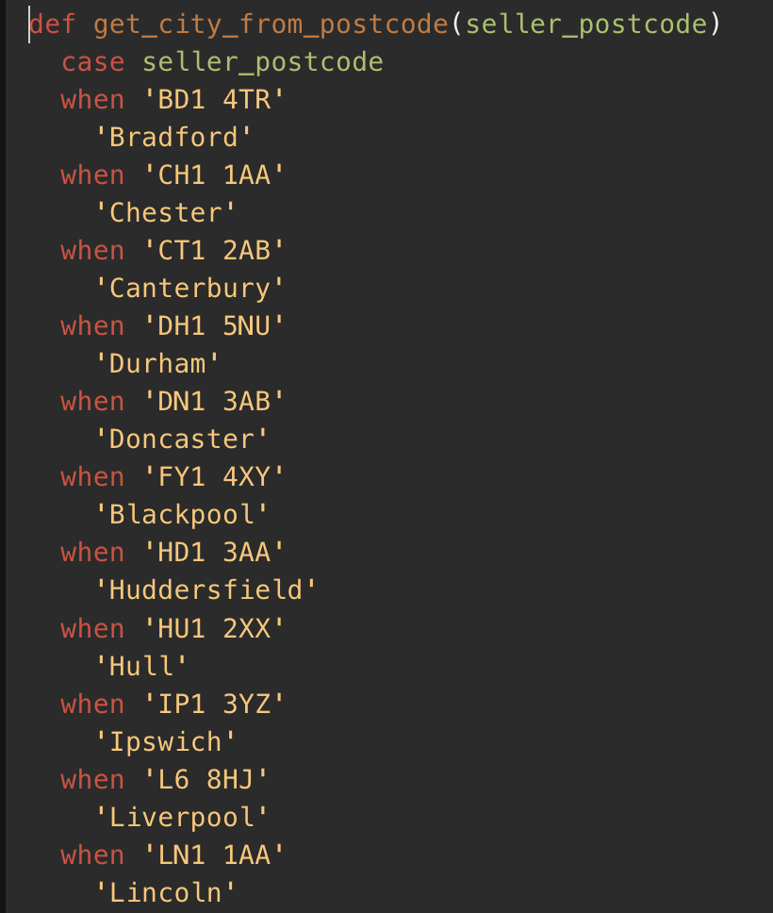

**Promotion**

promotion_end_date

Promotion end date must be greater than promotion start date by the days range from 10 to 30.

